G98C Specification
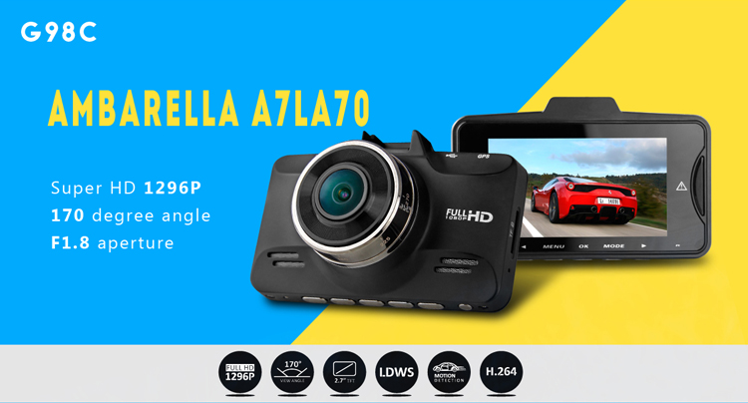

G98C is a state-of-the-art dash cam that supports the 2560×1080 as well as the 1296p formats. It records very good video quality both at day and at night, and supports ADAS Calibration like LDWS, FCWS, PDSW, HBM, TSR, etc. You could go for this one if you are looking for great video footage at the highest resolutions available with ADAS in 2015.
This Car DVR is a great aid for driving and proves their worth in many different situations. They could record your memorable precious moments of your life and those recorded videos could also prove great evidence for some undesirable happenings .I This camera records in a continuous loop so you could never miss a thing but the G-Sensor helps this device to save those important files from being overwritten which has recorded some important information and this Car DVR always protecting you when driving anywhere at anytime.
This little device gives you big peace of mind and security of your Car.
Glossary :
ADAS : Advanced Driver Assitance System
LDWS: Lane Departure Warning System
FCWS: Forward Collision Warning System
PDSW: Pedestrian Detection System
HBM: High Beam Assist
TSR: Traffic Sign Recognition

Main Features:
178 degree super wide angle lens.
2304*1296/30fps high definition resolution.
Advanced H.264 video compression technology.
2.7 inch high resolution LCD, can view while recording.
Support HDMI high quality video transmission.
G-Sensor to Locks the Crucial videos of the incidents
Loop recording with seamless, does not leak second.
Video recording supports record Date & Time stamp for each file.
Watching video simultaneous while driving, supporting on-spot play back.
When it re-starts no need to re-set the Time & Date.
A key to lock function
Motion detection function
Automatically turn on/off function
Can charge and data transmission through USB.
Equipped with special car fixed sucker, easy to fix and use.
Maximum memory storage 64GB, or TF with more high capacity storage device.

Chipset | Ambarella A7LA70
Sensor | 5.0 MP COMS
Screen Size | 2.7 Inch TFT LCD Screen
Color | BLACK
LensAngle | 178 degree wide angle lens
HDR Function | YES
Aperture Range | F1.8
Focel Distance | f=2.8mm
Decode Format | H.264
Video Resolution | 2304*1296P(30fps)  2560*1080P(30fps)  1920*1080P(60fps)  1920*1080P(30fps)  HDR 1920*1080P(30fps)  1280*720P(60fps)  1280*720P(30fps)
Video Format | MP4
Photo Resolution | 16M(5312*2988)13M(4800*2700) 9M(4000*2250) 4M(2688*1512)
Photo Format | JPG
G-Sensor | YES
Screen Resolution | 960*240
Loop-cycle recording | Off/1min/3min/5min
Frequency | 50HZ/60HZ
TV mode | PAL/NTSC
HDMI output | YES
Language | English/Chinese/Russian/Polish/Dutch/Czech/Deutsch/French
Time Stamp | YES
Auto-Power On | YES
Auto-Power OFF | OFF/1min/3min/5min
Delay Shutdown | OFF/15sec/30sec/1min
Microphone | YES
AV interface | Mini HDMI
Data interface | Mini USB
Working voltage | DC 12~24V
Power Interface | 5V 1.5A
Storage Expansion | TF Card up to 64G
Battery | Lithium battery 190mAH
Product weight | 134g
Product size(L*W*H) | 8.5*5.4*3.8cm
Package contents | 1 x G98C Car DVR Recorder  1 x Car Charger  1 x Mount Bracket  1 x USB Cable  1 x User Manual

